OUM
AN.100 FUNCTIONAL SPECIFICATION
ARCS Commentary Automation

Author: Vinit Dwivedi
Creation Date: 04-June-25
Last Updated: 04-June-25
Document Ref:
Classification Internal
Version: 1.0

DOCUMENT CONTROL

CHANGE RECORD
4
Date | Author | Version | Change Reference
04/06/2025 | Vinit Dwivedi | 1.0

APPROVAL
Approver | Position | Version
ARCS Working Group | ARCS Working Group

REVIEWERS
Name | Position
Himesh KANDPAL
Arvind Murthy
Kamal Ahmad
Ankit Chandra

DISTRIBUTION LIST

Name | Position
Library Master
Note to Holders:
If you receive an electronic copy of this document and print it out, please write your name on the equivalent of the cover page, for document control purposes.
If you receive a hard copy of this document, please write your name on the front cover, for document control purposes.

RELATED DOCUMENTS
No | Reference Document Name | Description

DEFINITIONS/ACRONYMS

Acronym | Definition
NWG | Natwest Group
GL | General Ledger
RGL | Oracle EBS GL (On-premise)
FGL | Oracle Fusion GL (On-cloud)
EDMCS | Separate module of Oracle used for maintaining master data. Includes reference data such CoA values, cross validation rules, etc.
FDS | Finance Data Store
FRC | Finance Reporting Cube
ARCS | Account Reconciliation Cloud Service
RC | Reconciliation and Compliance module within ARCS
TM | Transaction Matching module within ARCS
ICO | Intercompany
ICP | Intercompany Partner
LRC | Ledger Reporting Cube allows the detailed analysis of FGL Actuals data through an Essbase reporting cube
LRS | Ledger Reporting Store is a relational database that provides standard reporting capability for financial control using hierarchical roll-ups
OIC | Oracle Integration Cloud
OU | Organisational Unit is an FGL Segment which is unique to a franchise and belongs to one LE
PaaS | Platform as a Service
FGL | RBS General Ledger
SLA | Service Level Agreement
SSR | Source System Reconciliation

CONTENTS
Contents
1 DOCUMENT CONTROL ii
1.1 CHANGE RECORD ii
1.2 APPROVAL ii
1.3 REVIEWERS ii
1.4 DISTRIBUTION LIST ii
1.5 RELATED DOCUMENTS iii
1.6 DEFINITIONS/ACRONYMS iii
2 CONTENTS 5
3 OVERVIEW 6
3.1 PROJECT BACKGROUND 6
3.2 PURPOSE OF THE DOCUMENT 6
3.3 SCOPE 6
3.4 BUSINESS REQUIREMENTS 6
4 ARCS 8
4.1 HIGH LEVEL DESIGN 9
4.1.1 ARCS COMMENTARY AUTOMATION FROM UI PATH 9
4.1.2 Changes in ARCS……………………………………………………………………………………….10
4.2 Appendix 11

OVERVIEW

PROJECT BACKGROUND
Oracle Account Reconciliation tool (ARCS) has been chosen as the strategic tool by the Natwest Group to meet all reconciliations, attestation, and substantiation needs. We are trying to create ARCS Commentary Automation from Ui Path

PURPOSE OF THE DOCUMENT
The purpose of this document covers the mismatches report creation. This design is created based on the agreed requirements as per AN100/Non-Functional Requirements for the project.

SCOPE
Scope of the document is to understand the basic requirement of Mismatch Reports.

BUSINESS REQUIREMENTS
Ref. | Requirement Description | MoSCoW | ARCS Fitment
 | ICO team will send the Upload file over email on the provided email id (Arcs Upload File). The email should be sent with the Subject having 'ARCS' as the keyword for Bot to identify. | Must have | Email Identification
 | Bot will pick all the emails with 'ARCS' as the keyword sent by the ICO preparers. | Must have | Email Filtering
 | Bot will First Authorize the email id of the Sender with the list of Authorizers for Preparers provided. | Must have | Email Authorization
 | Bot will Authorize the Preparer and Reviewer email provided in the upload file with the list for authorizers provided. | Must have | Email Authorization
 | Bot will check whether the Sender email and the Preparer email in the file are same or not. | Must have | Email Verification
 | Bot to Prepare the upload file. | Must have | File Preparation
 | Split the data into two new .csv files based on the Transaction column ('adjustment to source system' and 'adjustment to subsystem'). | Must have | Data Splitting
 | The data to upload should be considered till column Z and save as .CSV file. | Must have | Data Saving
 | Open the URL https://epm-natwestepm3.epm.em3.oraclecloud.com/arm/vb/index.html?page=ecvbs-v2 | Must have | URL Access
 | Click on Period drop down to update the Period provided in the ARCS Upload file and then Click Reconciliation icon. | Must have | Period Update
 | Click on Action icon > then click on Import>> 'Import Pre-mapped Transaction'. | Must have | Import Action
 | Select the fields as per file that is required to be uploaded. | Must have | Field Selection
 | Click on Choose file to upload the CSV file you have prepared 'Adjustment to source System' or 'Adjustment to Sub System'. | Must have | File Upload
 | Select current reporting period. | Must have | Period Selection
 | Click on Import. | Must have | Import Action
 | Claim reconciliation one by one by the mismatch reference. | Must have | Reconciliation Claim
 | In case of any error, BOT should send the error file to the sender. | Must have | Error Handling
 | Save the upload CSV file in the Success Folder and send a success email with the uploaded CSV file to the Preparer Copying the Reviewer. | Must have | Success Handling
 | Save the upload CSV file in the Error folder and send the error email with the uploaded CSV file along with the error file downloaded from ARCS to the Preparer copying the Reviewer. | Must have | Error Handling
 | Post the above-mentioned import process, ARCS will populate the below screen providing the error. | Must have | Error Display
 | Click on the Error Excel file and then an Import error file will be downloaded. | Must have | Error File Download
 | Send the Import Error file along with the error email to be sent. | Must have | Error Email
 | Select the Individual Mismatch Reference one by one which are uploaded by BOT to Claim and Submit. | Must have | Mismatch Reference Selection
 | Click the empty field given below and paste a reference and wait for it to appear in the ARCS table. | Must have | Reference Pasting
 | Click on the mismatch reference that appears after above step by clicking on Name column. | Must have | Mismatch Reference Click
 | Click on Claim. | Must have | Claim Action
 | Click on the comment symbol and update the preparer name before the Rec comment provided in the arcs upload file. | Must have | Comment Update
 | Attach email backup wherever provided. | Must have | Email Backup
 | Click on Submit. | Must have | Submit Action
 | Repeat above steps till the comments are updated for all mismatch reference provided in excel files. | Must have | Comment Update
 | Bot to send confirmation back to sender of file for successful completion / error along with error screenshot and excel file. | Must have | Confirmation Email
 | At EOD, bot to send the full list of data that was uploaded in ARCS as part of control check to the Authorizer list provided. | Must have | EOD Report
 | Adding two custom attributes in profiles Preparer name, Reviewer Name | Must have | For Auditing the report
 | Update the Report in ARCS with the updated attributes | Must have | Auditor can be able to track who is the preparer and reviewer for each recon commentary
 | Bot is required to run every four times a day from 9:00AM IST till 9:00PM IST. | Must have | Bot Scheduling

ARCS
This section outlines functional requirements within ARCS.

HIGH LEVEL DESIGN

ARCS Commentary Automation from UI Path
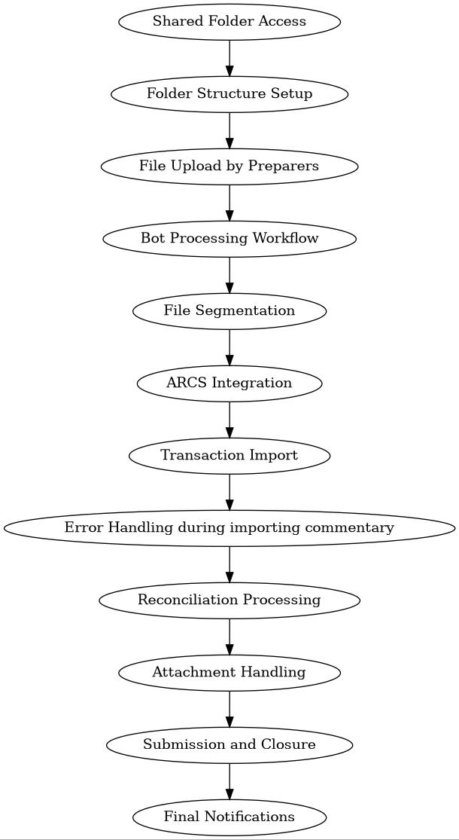

To streamline the commentary process, we propose the following automation workflow using UiPath:

1. Shared Folder Access
The bot will be granted access to a shared folder, similar to how users access it via SLX.
This shared folder will serve as the central hub for all input and output data.

2. Folder Structure Setup
Within the shared folder, two main directories will be created:
Inbox: For receiving data from business users.
Outbox: For storing processed and backup data.
Inside the Inbox, subfolders will be created for each preparer responsible for commentary.
Access to each subfolder will be restricted to the respective preparer and their assigned reviewer.

3. File Upload by Preparers
Preparers will upload their commentary files to their designated subfolders.
Instead of using email, SharePoint will be used for better feasibility and control.

4. Bot Processing Workflow
The bot will:
Monitor each subfolder.
Open the uploaded file.
Validate the preparer and reviewer names.

5. File Segmentation
The bot will split the commentary file into two CSV files:
One for Source System transactions.
One for Subsystem Adjustments.

6. ARCS Integration
The bot will:
Log into the ARCS production application.
Select the correct period as specified in the commentary file.
Open the relevant reconciliation card.

7. Transaction Import
Using ARCS’s “Import Pre-Mapped Transactions” functionality:
The bot will import both CSV files.

8. Error Handling during importing commentary
Download the error file from ARCS.
Send an error email with the error file to the preparer (CC reviewer).

9. Reconciliation Processing
For each reconciliation mentioned in the files:
The bot will claim the reconciliation.
Add comments and attachments.

10. Attachment Handling
Business users must provide a mapping file that includes:
Account ID
Attachment Name
Alternatively, they can use the same commentary file with an added column for attachment names.
For each Account ID:
A ZIP file should be created containing all relevant attachments.
This allows the bot to upload all attachments at once.

11. Submission and Closure
After adding comments and attachments:
The bot will submit the reconciliation.
Close the current reconciliation.
Repeat the process for the next one.

12. Final Notifications
The bot sends a confirmation email with success or error details.
At EOD, the bot sends a full upload report to the authorizer list.
Bot runs every 4 timesfrom 9:00 AM to 9:00 PM IST on WD8–18:

changes in arcs

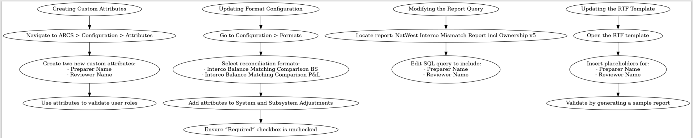

To enable UiPath to automate the reconciliation commentary process effectively, specific configurations must be made within the ARCS (Account Reconciliation Cloud Service) environment. These changes ensure that the automation bot can access, validate, and process the necessary metadata during reconciliation workflows.

1. Creating Custom Attributes
Objective: Capture metadata for automation validation.

Navigate to ARCS > Configuration > Attributes.
Create two new custom attributes:
Preparer Name – to identify the user who prepared the reconciliation.
Reviewer Name – to identify the user responsible for reviewing the reconciliation.
These attributes will be used by the UiPath bot to validate user roles before processing commentary and attachments.

2. Updating Format Configuration
Objective: Integrate custom attributes into reconciliation formats.
Go to Configuration > Formats.
Select the following reconciliation formats:
Interco Balance Matching Comparison BS
Interco Balance Matching Comparison P&L
Within each format:
Navigate to the System Adjustments and Subsystem Adjustments sections.
Add the Preparer Name and Reviewer Name attributes.
Ensure the “Required” checkbox is unchecked for both attributes. This allows the bot to process reconciliations even if these fields are not manually filled, as the bot will populate them during automation.

3. Modifying the Report Query
Objective: Ensure reporting includes new attributes for visibility and validation.

Locate the report: NatWest Interco Mismatch Report incl Ownership v5.
Edit the SQL query behind the report to include:
Preparer Name
Reviewer Name
This ensures that the report reflects the updated reconciliation metadata and allows stakeholders to track who prepared and reviewed each reconciliation.

4. Updating the RTF Template
Objective: Display new attributes in the final report output.

Open the RTF (Rich Text Format) template associated with the above report.
Insert placeholders for:
Preparer Name
Reviewer Name
These placeholders will dynamically populate with data from the reconciliations when the report is generated.
After updating, validate the RTF by generating a sample report and confirming that the new fields appear correctly with accurate data.

Appendix

